**DAILY ONLINE ACTIVITIES SUMMARY**

|  |  |  |  |  |  |  |  |  |
| --- | --- | --- | --- | --- | --- | --- | --- | --- |
| **Date:** | **17/06/2020** | | | | | **Name:** | **NAIPUNYA VINOD NAIK** | |
| **Sem & Sec** | **IV SEM & A SECTION** | | | | | **USN:** | **4AL18CS050** | |
| **Online Test Summary** | | | | | | | | |
| **Subject** | | **NO INTERNALS CONDUCTED** | | | | | | |
| **Max. Marks** | | **-------------** | | **Score** | | | **-------------** | |
| **Certification Course Summary** | | | | | | | | |
| **Course** | **1)** LEARN PASSWORD,WIFI,OS-HACK-STARTER GUIDE  **2)** ZERO TO HERO IN MICROSOFT EXCEL: COMPLETE EXCEL GUIDE 2020 | | | | | | | |
| **Certificate Provider** | | | **UDEMY** | | **Duration** | | | **1) 6 HRS**  **2) 34MIN** |
| **Coding Challenges** | | | | | | | | |
| **Problem Statement:-1)** [Find the smallest positive integer value that cannot be represented as sum of any subset of a given array sorted in ascending order.](https://github.com/orgs/alvas-education-foundation/teams/2nd-year/discussions/124)  **2)** [Write a C Program to Count numbers that don’t contain 3](https://github.com/orgs/alvas-education-foundation/teams/2nd-year/discussions/123). | | | | | | | | |
| **Status:-EXECUTED** | | | | | | | | |
| **Uploaded the report in Github** | | | | | **YES** | | | |
| **If yes Repository name** | | | | | <https://github.com/naipunya-naik/lockdown-coding/blob/master/C%20CODING/Countnumber_17-06-2020.c>  <https://github.com/naipunya-naik/lockdown-coding/blob/master/C%20CODING/smallest%20positive%20integer_17-06-2020.c> | | | |
| **Uploaded the report in slack** | | | | | **YES** | | | |

Online Test Details: (Attach the snapshot and briefly write the report for the same)

NO INTERNALS CONDUCTED

Certification Course Details: (Attach the snapshot and briefly write the report for the same)

TODAY I COMPLETED TWO CERTIFICATION COURSES.

CERTIFICATION COURSE NAME:- LEARN PASSWORD,WIFI,OS-HACK-STARTER GUIDE



2)CERTIFICATION COURSE NAME:- ZERO TO HERO IN MICROSOFT EXCEL: COMPLETE EXCEL GUIDE 2020



Coding Challenges Details: (Attach the snapshot and briefly write the report for the same)

PROBLEM STATEMENT 1:- [Find the smallest positive integer value that cannot be represented as sum of any subset of a given array sorted in ascending order.](https://github.com/orgs/alvas-education-foundation/teams/2nd-year/discussions/124)

Top of Form

Bottom of Form

|  |
| --- |
| Given a sorted array (sorted in non-decreasing order) of positive numbers, find the smallest positive integer value that cannot be represented as sum of elements of any subset of given set Examples:  Input: arr[] = {1, 3, 6, 10, 11, 15}; Output: 2 There are no one or more elements to be added up to get sum = 2  Input: arr[] = {1, 1, 1, 1}; Output: 5 1 = 1, 1+1 = 2, 1+ 1 + 1 = 3, 1 + 1 + 1 + 1 = 4, There is no elements in the array to get sum 5  Input: arr[] = {1, 1, 3, 4}; Output: 10 1 = 1, 1 + 1 = 2, 3 = 3, 1 + 3 = 4, 1 + 4 = 5, 1 + 1 +4 = 6, 3 + 4 = 7........ To get sum 10, there is no elements in the array.  Input: arr[] = {1, 2, 5, 10, 20, 40} Output: 4 There are no elements to get sum = 4.  Input: arr[] = {1, 2, 3, 4, 5, 6} Output: 22 |

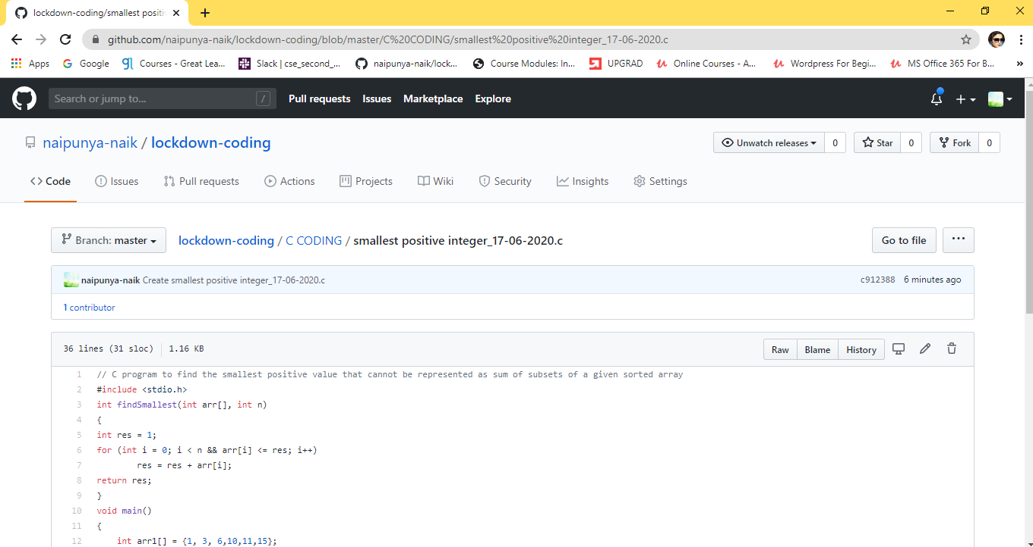

GITHUB REPOSITORY LINK:-

<https://github.com/naipunya-naik/lockdown-coding/blob/master/C%20CODING/smallest%20positive%20integer_17-06-2020.c>

PROBLEM STATEMENT 2:- Write a C Program to Count numbers that don’t contain 3

Top of Form

Bottom of Form

|  |
| --- |
| Given a number n, write a function that returns count of numbers from 1 to n that don’t contain digit 3 in their decimal representation. **Examples:** **Input:** n = 10 **Output:** 9 Here input is 10 means the numbers within 10 are 1,2,3,4,5,6,7,8,9,10 in this series 3 occurs only 1 times so answer is 9  **More examples** Input: n = 45 Output: 31 // Numbers 3, 13, 23, 30, 31, 32, 33, 34, // 35, 36, 37, 38, 39, 43 contain digit 3.  Input: n = 578 Output: 385 |

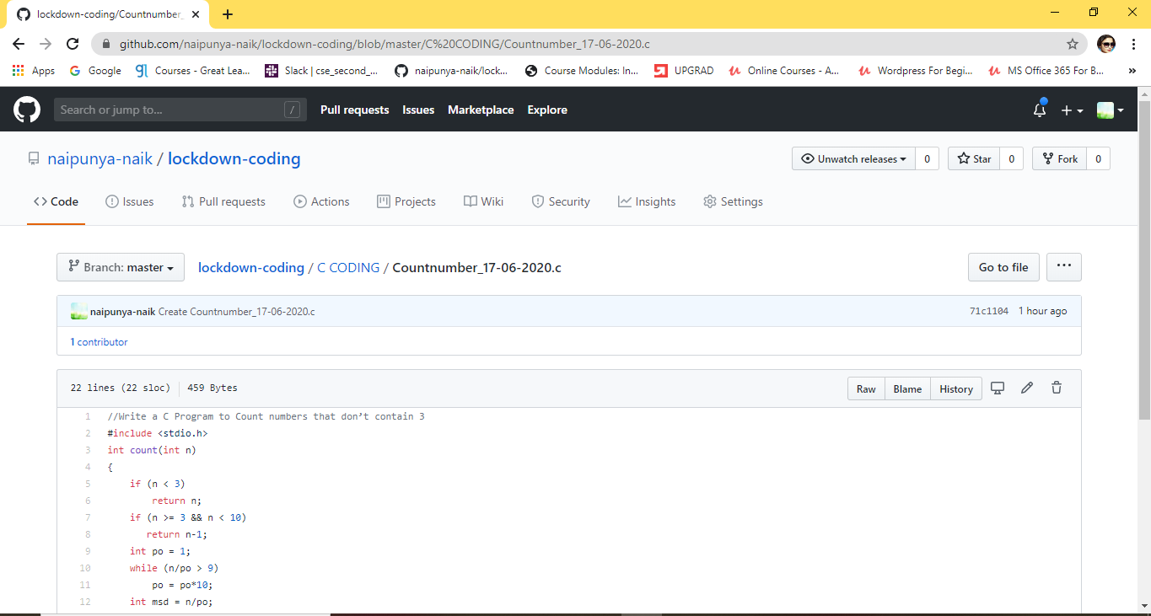

GITHUB REPOSITORY LINK:-

<https://github.com/naipunya-naik/lockdown-coding/blob/master/C%20CODING/Countnumber_17-06-2020.c>